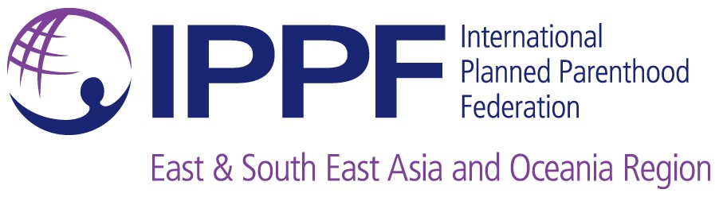 | Sub Regional Office for the Pacific  BSP Life Centre (Level 4),  Thomson Street  P.O. Box 13918, Suva, FIJI  Tel: (679) 3315 624 / 3315 625  Fax: (679) 3315 656

INTERNATIONAL PLANNED PARENTHOOD FEDERATION
(IPPF)

JOB DESCRIPTION

Job Title:  Senior Programme Officer, Partnerships for Health |  | Division:  Restricted Programmes
Location:  Suva, FIJI |  | Responsible to:  Senior Programme Manager, Partnerships for Health and Rights Programme
1. JOB PURPOSE
Describe why the job exists
 | The Senior Programme Officer (SPO) role is to lead technical oversight and ensure implementation of the Partnerships for Health Project on time and within budget. Provide management oversight of the Samoa Bilateral program and other restricted funding activities across the eight (8) Member Associations (MAs) in the Pacific Region for IPPF. To provide technical support and capacity building to the Pacific MAs as required for the efficient and effective planning, implementation, monitoring and reporting of all restricted MA programmes. Work closely with Head of the Sub-Regional Office for the Pacific (SROP) and SPRINT (humanitarian programmes) team to ensure integrated workplanning and implementation of IPPF programmes across the Pacific.
2. KEY TASKS
Please describe the main activities undertaken by the job holder. The list need not be exhaustive, but should reflect the most important features of the job.
- Lead the development of Integrated MA Annual Programme Budgets (APBs) and assist to improve quality of APBs and Annual Reports across 8 Pacific Island Countries.
- Manage restricted funding activities implemented by MA’s in 8 Pacific Island Countries.
- Monitor all programme reports (Annual reports, special reports, etc) and provide support as necessary. Select special programmes based on this monitoring and encourage MAs to document lessons learned and success stories.
- Review program report template and develop appropriate template for donor funding reporting highlighting program deliverables and incorporating the M&E framework
- Ensure the MAs understand the importance and process of Programme Management and ensure that all programmes are written out with a results based management framework, with proper and adequate indicators.
- Provide guidance to MAs to identify their needs and develop projects to respond to their needs and needs of their country.
- Assist MAs to understand and develop policies that are in line with IPPF policies and standards.
- Undertake capacity building development activities for MAs in the area of organizational management, governance, programme management and sustainability.
- Ensure quality, timely reports to all donors.
- Implement innovative systems to strengthen systematic delivery of SRH services to the target population.
- To keep updated of latest developments/techniques in the area of sexual reproductive health and rights and identify best practices in SRHR.
- To be available for consultation and assistance as and when needed.
- To undertake any other duties assigned from time to time.

 | 3. EDUCATION & QUALIFICATIONS
- MA/Degree in health, social policy or management with at least 8 years of relevant experience with a development or health related agency.
- Experience in managing Pacific regional programs.
- Proficiency in writing, communications, management and human relations.
- Management of high performing teams.
- Experience in managing DFAT programs will be highly regarded.
- Experience in sexual and reproductive health programs will also be highly regarded.

 | 4. PROVEN ABILITY
 | At least five years working experiences in a similar position in any organization, preferably a civil society organization or small business.
 | 5. SKILLS
- High quality communication skills, both verbal and written.
- Skills in capacity development, including coaching and facilitation.
- Project management skills, including monitoring and evaluation.
- Skills in organizational development, such as strategic planning, financial management and human resource management.
- Computer literacy.
- Fluency in English
- Able to work cross-culturally

 | 6. PERSONAL COMPETENCE
- Able to discuss sensitive issues with empathy and consideration of different perspectives.
- Ability to identify priorities under pressure and to complete tasks effectively under pressure, meeting deadlines.
- Ability to maintain confidentiality
- Excellent time management and organization of work load.
- Must be able to work both independently and as part of a team.
- Commitment to ongoing learning and quality improvement.
- Able to take initiative.
- Reliable, self-motivated and flexible; able to respond to new opportunities
- Commitment to the aims of IPPF.

Signed: ……………………… Date: ………………………………..

